Anomaly Detection Using Data Analytics for Java Based Applications


Group - 21
Supervisors

External - Dr. Srinath Perera
srinath@wso2.com
Internal - Dr. Amal Shehan Perera
shehan@cse.mrt.ac.lk

Evaluation Panel

Dr. Indika Perera
Mrs. Sandareka Wickramanayake

Team members
K.Kokulan - 120314K
K.Linganesan - 120337H
I.Suventhan - 120649P
M.V.Vithulan - 120678D

Contents
1. Problem statement 3
2. Motivation 4
3. Objectives 4
4. Project output 4
5. Project outcome 5
6. Literature review 5
7. Requirements Specifications 5
7.1. User Classes and Characteristics 5
8. Design Specifications 5
8.1. System Overview 5
8.2. Abstract Architectural Diagram 5
8.2. Activity Diagram 5
9. Proposed solution 5
References 7

Table of Figures

Problem statement
How can we perform the collection, processing and analyzing of JFR that allows users to gain the following analysis mechanisms such as, detect anomalies/ using machine learning algorithms?

2. Motivation
Java Mission Control (JMC) and other major Java profilers do visualize the performance details and we can manually perform analysis on those visualized events to diagnose performance bottlenecks. However, manually inspecting JFR outcome to detect anomalies is unfeasible due to the increasing scale and complexity of systems [36]. JMC doesn’t have the feature of auto analysis part on JFR up to now. If we employ such algorithms to analyze JFR events and automatically show the performance insights, it will be a big time saving tool for a lot of programmers and developers all around the world.

Also, currently available profiling tools doesn't have any feature to detect anomalies. So, if we employ machine learning algorithms such as signature-based methods or data mining-based methods which rely on labelled training data or using unsupervised anomaly detection techniques will enable the system to be trained with unlabeled/labelled data and is capable of detecting previously “unseen” anomalies [35]. We have multiple options and algorithms to detect anomalies and automate performance analysis which were already researched by many scientists. JFR has a better detailed data structure of events which can be organized in meaningful ways. Anomaly detection first defines a profile of normal behaviors, which reflects the health and sensitivity of a JFR structure. Correspondingly, an anomaly behavior is defined as a pattern in JFR data that does not conform to the expected behaviors.

The goal of anomaly detection is to target any event falling outside of a predefined set of normal behaviors and the goal of automation is to eliminate the manual analysis.

3. Objectives
A tool which can,
- Parse JFR binary
- Analyze the data using machine learning algorithms.
  - Detecting anomalies
  - Automating performance analysis
- Produce a dashboard/report

4. Project output
A tool where we can upload and analyze JFR files which will extract and present insights of Java application performance.
Blog - http://theanomaliez.blogspot.com/
Publish research papers to related conferences.
- IEEE - International Conference on Software Engineering / International Conference on Automated Software Engineering
- ACM
- International Conference on Machine Learning and Soft Computing
- Innovation in Software Engineering Conference
- Asia-Pacific Software Engineering Conference
- Australasian Computer Science Conference

5. Project outcome
Targeted main users of our project are, developers and programmers all around the world. This tool will be useful to predict anomalies in production system and automate the process while finding the bottlenecks to provide a better service to users and eventually it will save a lot of time for programmers from debugging the code.

6. Literature review

6.1. Introduction
Different names for the anomaly detection problem as used in literature are: outlier detection, surprise detection, discord detection, deviation detection, exception detection and one-class classification. The machine learning version of anomaly detection aims to build a model that can differentiate anomalous instances from the rest of the data. Techniques can operate in one class or multiclass setting. In one class setting, all anomalous instances are treated as one class. In contrast, in multi-class setting, the goal is to learn different classes of an anomalous nature. Various methods have been proposed for anomaly detection, using concepts drawn from multiple disciplines. Many anomaly detection techniques have been specifically developed for certain application domains, while others are more generic. In the domain of anomaly detection in software applications, there are very few research papers have been released. Therefore these research papers that we are reviewed are not directly in the domain of software anomaly detection, but in a more likely domains such as intrusion detection, network security, etc.

Our project is to analyze and detect anomalies in Java Flight Recorder (JFR) file, which is contains diagnostic and profiling data about a running Java application. Anomaly detection remains a challenging research topic. It is often difficult to specify a concrete definition of normal regions as opposed to abnormal regions. For that reason, techniques in anomaly detection are usually domain-specific. The lack of labelled data is a common problem. This gives rise to the popularity of techniques operating in unsupervised or semi-supervised mode. Unsupervised anomaly detection does not require training data. However, it makes implicit
Assumption about the unbalanced distribution of the data set. Thus, the techniques report high false alarm rate if this condition does not hold. On the other hand, techniques that operate in semi-supervised mode require only normal examples for training. In practice, it is often more feasible to collect instances of the normal class than to obtain a comprehensive set of anomalies. This is the approach that our method uses.

We researched on several algorithms by considering the suitability and adaptability to our domain and we concluded them to three.
- Markov model
- Clustering
- Recurrent neural network
This literature review will be reviewing these three algorithms in such a way: methodologies, time series adaptability to algorithms and their applications that are reviewed in literature.

6.2. Markov Model

Markov model is a stochastic process model specifies how a random variable changes in time. It assumed that the probability distribution of the next state depends on the current state and does not depend on the previous states leading to the current state. [1] It is also called as Markov property. The Markov property in mathematical form,
P (X_{n} = x|X₀, . . . ,X_{n−1}) = P (X_{n} = x|X_{n−1}) ∀n∀x

The Markov model can be used to model an extraordinarily large number of applications such as weather, economic data, music and more. Figure below show the classification of the markov model based on the system type and states.
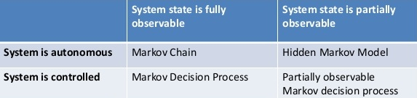

6.2.1. Markov chain
Markov chain is discrete time stochastic process that undergoes transitions from one state to another on a state space. It is required to possess a Markov property that is usually characterized as “memoryless”: the probability distribution of the next state depends only on the current state and not on the sequence of events that preceded it. Also the state transition from time t to t+1 is independent of time. Let P(i, j) denote the probability that the system is in a state j at time t+1 given the system is in state i at time t. If the system has a finite number of states, 1, 2, …, s, the stationary Markov chain can be defined by a transition probability matrix[1]:
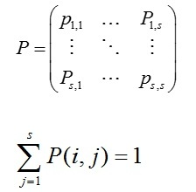
And initial probability distribution
Q = q1, q2, ....., q_{s}
where qi is the probability that the system is in state i at time 0.

6.2.2. Hidden Markov Model
Hidden Markov model is a statistical Markov model in which the system being modeled is assumed to be a Markov process with unobserved (hidden) states. HMM-based classification technique offers an opportunity to determine unobservable hidden behaviors of complex and remotely inaccessible electronic systems using observable signals.

HMM is an extension of Markov chain, which includes double stochastic process: one is Markov process express by states which are hidden; the other is observations sequence associate with states. In each state, there will be observations in accordance with the specific probability distribution which can be observed [2]. Literature [3] introduced HMM into anomaly detection for the first time, which used sequence of system calls to build normal model of process, and experiments show that HMM achieved best detection result in short sequence model, frequency model and data mining. In literature [4] used 10 to 40 hmm training models to find the best output, and proposed that “while performing experiments we find the number of states is a sensitive parameter, but there is no theoretical base to determine it, only way to determine this parameter is through many experiments with different number of states”. After this several researches happen in recent years to find the method to determine the parameter, but there is still not good solution on this problem. Literature [5] proposed that using hmm for credit card fraud detection and improving time series classification provide more advantages such as better accuracy, more reliable, improve the classification, and predicts the future events for the systems.

6.2.2.1 Theory of HMM
Hidden Markov Model model time series data. The Markov model is too restrictive to be applicable to many problems of interest. Therefore markov model concept is extended to hidden markov model. The resulting model is a doubly stochastic process with an underlying stochastic process that is not observable (it is hidden), but can only be observed through another set of stochastic processes that produce the sequence of observations[6].

HMM can be denoted as triples λ = (A, B,π ) :
- Transition probability a_{ij} = P(qj | qi ); which is the probability of state qi shift to state qj. If there are N states, there would be N×N transition probabilities. A is matrix of them.
A = [aij] And j=1Naij = 1
- Observation probability b_{j(k)} = P(ok | qj ); which is the probability of observation ok under the state of qj. If there are M observations, there would be N×M observation probabilities. B is matrix of them.
B = [bj(k)] And k=1Mbj(k) = 1
- Initial state probability: which means the probability of occurrence state qi (i=1,2,…,N) when t=0.

6.2.2.2. Three classic problems in HMM
- Evaluation Problem
HMM λ = (A , B , π ) and the sequence of observations O = [ o 1 , o 2 ,..., o T ] has been known. Find the probability of this sequence generated by given HMM λ. Also experiment with multiple HMM models to find the best matches HMM model for given observation sequence [5]. Forward algorithm used to solve the evaluation problem.
- Decoding Problem
HMM λ = (A , B , π ) has been known. Find the sequence of hidden states which can be produce a specific sequence of observations. Decoding problem solved by Viterbi Algorithm.
- Learning Problem
Find parameters of the HMM λ = ( A , B , π ) such as transition probabilities and emission probabilities using given observation sequences and the hidden states. Baum-Welch algorithm or forward - backward algorithm used to solve the learning problem.

6.2.3 Applications - Credit Card Fraud Detection
Demand for access to online shopping is increasing rapidly with the most popular method of payment being the credit card. Credit cards are used for purchasing goods and services using online transaction or physical card for offline transaction. In physical card based purchase, the person doing fraud has to steal the card. In online payment mode attackers need only little information for doing false transaction example secure code, expiration date, card number and many other factors. Most of the time card holder is not aware that someone else has seen or stolen his card information. The only way to detect this kind of fraud is to analyze the spending patterns on every cardholder and to figure out any irregularity with respect to the “usual” spending patterns. Fraud detection based on the analysis of existing purchase data of cardholder is a promising way to reduce the rate of credit card fraudulent activities. Several techniques proposed and used for credit card fraudulent detection in the last few years. Literature [20], [23] says HMM model is the best method to detect the credit card fraudulent.

In HMM method, first generate the observation sequences for each cardholder using the spending behavior of the cardholder, then using generated sequences HMM model was created eventually using Baum-Welch algorithm. This also known as learning in HMM. After the HMM models are learned, evaluate the model using observation test data. For this they generated the sequence of length N and calculate the accepted probability of this generated the sequence by given HMM model. In this way they evaluate several sequences of same length N by removing the initial value and add the next new value and get accepted probability for these sequences. Difference between these accepted probabilities used say the fraudulent or normal by threshold value [5],[24].

6.3. Clustering
Clustering is a well-known and studied problem. There exist a large number of clustering algorithms in the literature. These methods can be categorized as: partitioning methods, hierarchical methods, density-based methods and grid-based methods. Clustering algorithms can be used to find out patterns in unlabeled data. The main advantage of clustering is that it is capable of detect novelty from the learning data itself. The user does not need to explicitly say the descriptions of anomalies. Therefore amount of training data that needs to be provided is reduced. We find out anomalies from clustering using outliers. In the context of clustering outliers are the clusters that are with low density or in relatively high distance from cluster centers and from the context of anomaly detection, outliers are the anomalies that are found in the data set [7].

6.3.1. Clustering time series data
Just like for statistical data clustering, time series data clustering also requires clustering algorithms to form clusters from unlabeled data set. Time series data distinctions can be concerned as multiple data or discrete valued or real valued, uniformly sampled or non-uniformly sampled, univariate or multivariate. In our case, JFR file data are almost univariate time series. Therefore we will consider only about univariate time series clustering algorithms.

There are many algorithms have been evolved to cluster different types of time series data, but ultimately what they all try to do is to modify existing algorithms in such a way that they can convert time series data into static data, so that existing algorithms for clustering can be directly used.

Clustering time series data are categorized into three types [12],

6.3.1.1. Raw data based approaches
This approach handles the methods that works with the time or frequency domain. Two time series will be compared and normally sampled at same interval.

6.3.1.1.1. Modified fuzzy C-means
Möller-Levet [8] suggested short time series distance to measure the similarity in shape formed but the relative change of amplitude and corresponding temporal information of uneven sampling intervals. Conventional clustering algorithms based on the Euclidean distance or the Pearson correlation coefficient are not able to include the temporal information in the distance metric. The temporal order of the data and the varying length of sampling intervals are important and should be considered in clustering time-series.

The objective is to define a distance which is able to capture differences in the shapes, defined by the relative change of expression and the corresponding temporal information, regardless of the difference in absolute values. We approach the problem by considering the time-series as piece wise linear functions and measuring the difference of slopes between them.

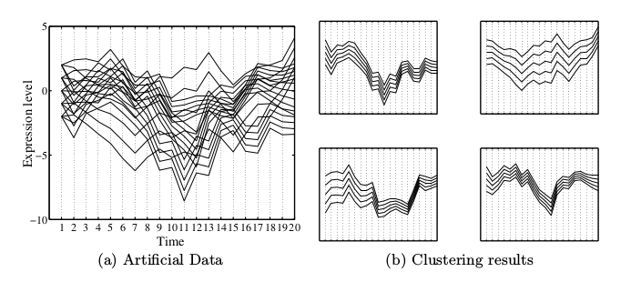

6.3.1.1.2. Agglomerative hierarchical
Shumway [9] investigated the clustering of non-stationary time series by applying locally stationary versions of Kullback–Leibler discrimination information measures that give optimal time–frequency statistics for measuring the discrepancy between two non-stationary time series. Finally an agglomerative hierarchical cluster analysis was performed until a final set of two clusters was obtained.
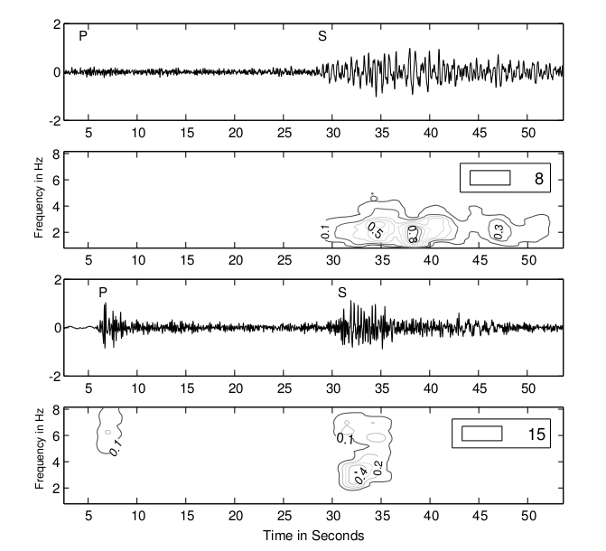

6.1.2. Feature based approach

It is not desired to work directly with raw data as it contains lot of noise that can cause unexpected results. Therefore several feature based approaches have been proposed to resolve this issue.

Modified SOM

In [10] Described the use of self-organizing maps for grouping data sequences segmented from the numerical time series using a continuous sliding window with the aim to discover similar temporal patterns dispersed along the time series.

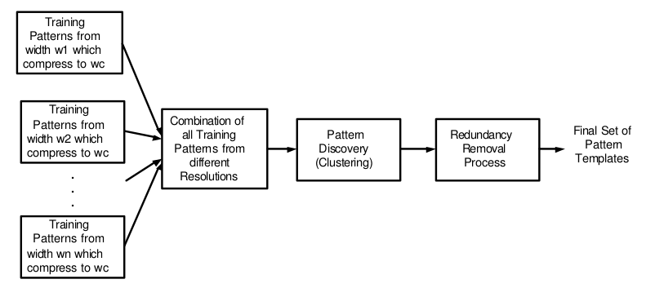

3.1.3. Model based approach

Agglomerative clustering

It's a Bayesian algorithm for clustering by dynamics. Given a set S of n numbers of univariate discrete valued time series, BCD transforms each series into a Markov chain and then estimate transition matrix from data and then we cluster transition matrices to discover the most probable set of generating processes [11].

The goal of this algorithm is to identify time series with similar dynamics. For example, some time-series doesn’t seems to look similar, but when we analyze their state transitions, there is a possibility that transitions occur similarly. M. Ramoni tried to find similarity in time-serieses using this methodology and clusters them.

Now we can cluster time-series so the next step is to find anomalies if it exists in the data.

3.2. Anomaly detection using clustering

Normally there exists two ways to detect anomalies from clustering for all types of data. The idea behind the first approach is that anomalous or attack data forms a small percentage of the total data. If this assumption holds, anomalies and attacks can be detected based on cluster sizes - large clusters correspond to normal data, and the rest of the data points, which are outliers, correspond to attacks

Idea behind second approach is we calculate the distance for the data points from the centroids of clusters and we define distance threshold values. If the distance of a data point is beyond the value of threshold we can define it as an anomaly. There are few ways to calculate distance to data points in clusters such as Euclidean distance and Mahalanobis distance [7]. Below two examples are obtained from the literature as a proof of anomaly detection in clustering.

Enhanced DBScan algorithm

The DBScan algorithm is a fundamental density-based clustering algorithm. Its advantage is that it can discover clusters with arbitrary shapes. The algorithm typically regards clusters as dense regions of objects in the data space which are separated by regions of low density objects. The algorithm has two input parameters, ε and MinPts. For understanding the process of the algorithm some concepts and definitions has to be introduced.

Enhanced DBScan Algorithm [21], In order to enhance the performance of the DBScan algorithm suggest using R* trees for determining the ε-neighborhood of an object. The R* tree is similar to the B-tree in a certain manner, namely, in both trees the distance equals between the root and the leaves, and the number of the children of each node is limited. This feature ensures that the processing time on this tree is logarithmic.

Mahalanobis distance based anomaly detection

This case following figure refers to the measurement of carbon monoxide during two months in the year of 2002. The data is hourly sampled, and was collected in a metropolitan area, by an automated monitoring system maintained. For reference, they have used its chemical representation, CO . Its cycle’s length is of 24 hours.

Result of the C-AMDATS [22] approach for this case, Three major patterns are highlighted: the red, green and blue, in order of anomaly score, which led us to select the patterns highlighted with red and green color as the anomalous patterns.

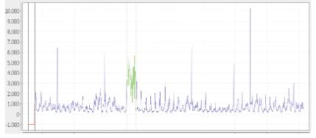
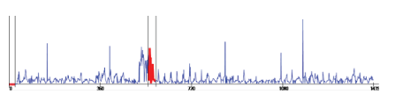

4. Neural Network for Anomaly Detection
Artificial Neural networks (ANN) have been used for classification-based anomaly detection[19]. A basic anomaly detection technique using ANN, operates in two steps. A neural network is first trained on normal examples to learn the different normal classes. Each test instance is then provided as input to this trained network. The network is supposed to reject an input if it is an outlier.

4.1. Recurrent Neural Network(RNN)
Recurrent neural networks (RNNs) are a subclass of Artificial Neural Networks. RNN differ from standard neural networks by allowing the output of hidden layer neurons to feedback and serve as inputs to the neurons. In this way the network is able to use past history as a way to understand the sequential nature of the data. For anomaly detection in time series, RNNs can be used as time series modelers[13]. RNNs are introduced as powerful sequence modelers of arbitrary length.

RNN is also known in literature as autoencoder. The basic idea of RNN is that the input vector is also the output vector. The output layer therefore has equally many nodes as the input layer. Instead of training to predict a target value y given an input x, the network is trained to reconstruct its own input x. The weights of the RNN is driven by the goal to minimize the reconstruction error rate.

Like HMMs, RNNs have hidden states. But, in contrast to HMMs, RNNs make a more efficient use of its hidden state [14]. In a HMM, the hidden state depends only on the previous state which must store possible configurations of the sequence. So to incorporate information about an increasing window of previous states, the hidden state must grow exponentially large making them computationally impractical. While in RNNs, the state is shared over time, the hidden state of a RNN contains information from an arbitrarily long window.

4.2. Long Short Term Memory (LSTM)
LSTMs have an advantage over traditional RNNs on tasks involving long time delays between events. A typical RNN with sigmoidal activation units suffers from what is called the ’vanishing gradient problem’ [15]. The problem causes to the loss of information with time due to decaying gradient values as one traverses backwards through layers during back-propagation. Some tasks require the network to extract information conveyed by the duration of intervals between these events. LSTM facilitate learning long term dependencies in the input.

For detecting outliers of a time series, Use LSTMs to build a prediction model, i.e. given current value, predict next few steps in the time-series. Then, error in prediction gives an indication of anomaly. For example, if prediction error is high, then it indicates anomaly. Prediction model based approach is better when anomalous instances are not easily available whereas a classifier based approach is more suitable when there are sufficient labeled instances of both normal and anomalous instances.

LSTM Encoder-decoder based approaches have been proposed for anomaly detection [16,17]. These approaches learn a model to reconstruct the normal data such that the learned model could reconstruct the subsequences which belong to normal behavior. The learnt model leads to high reconstruction error for anomalous or novel subsequences, since it has not seen such data during training.

4.3. Autoencoder and Anomaly detection
The optimal RNN has some expectation of the typical series. For detecting outliers of a time series, the reconstruction error is a good starting point. A ‘reconstruction error’ is the difference between the original time series and the reconstructed time series. A high reconstruction error at specific time indicates that there is a potential outlier at that time. Therefore, the square of the reconstruction error can be used as an anomaly score.

The RNN needs to learn what normal time series behavior is. So an autoencoder is used which can learn expected behavior by setting the target, y, to be the input, x. An autoencoder is a special neural network in which its input-layer and output layer have the same size (N-dimensions) and there is at least a hidden layer in the middle that connect two parts. The hidden layer’s size is smaller (K-dimensions, K < N) than input and output layer. The middle-hidden-layer is the new representation of compressing the input data. A simplest form of autoencoders with one hidden layer is show in the figure given below. The first part of the network (from the input to middle-hidden-layer) is called encoder since it encodes the input. The second part (from the middle-hidden-layer to output) is called decoder because it reconstruct the input from the middle-hidden-layer.

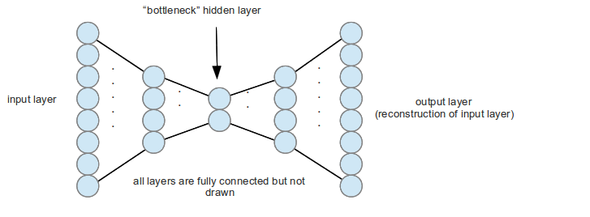

Some general statements can be made about how well the RNNs can find anomalies.[*]
- The windowed errors are a versatile way of finding both point and discord anomalies at multiple scales. However, this means that the window size must be about the same scale as the anomaly. Else, the effect of the anomaly would not be pronounced.
- The RNNs were insensitive to variations in sequence length and translation.
- The training data can have some anomalous data: as long as most of the data is normal, the algorithm seemed robust enough to have learned the pattern of the data with the anomaly in it.
- no domain knowledge applied: no expert in this kind of time series provided input on how to analyze this data

In general, subject to effective training, the RNNs learned the typical behavior of the series which includes information about their typical values as well as their ordering. Concludingly, the autoencoding recurrent neural network can be used to detect anomalies in sequences.

4. Summary
We have researched on other algorithms in machine learning for anomaly detection such as Support vector machine [25], One class Support vector machine [26], Bayesian networks [27], Association rule discovery [28], RIPPER [29], Principal components analysis (PCA) [30] and System call based sequence analysis [31] but as per literature surveys [7], [19], [32] it is suggested that HMM, Clustering and autoencoding are the best fitting techniques that can be applied for time series data and for unsupervised anomaly detection.

HMM models the time series that we feed, and then it can compute transition matrix and emission matrix. Then we should be able to find out the anomaly score of an observed sequence by calculating the probable of occurrence of it.

Clustering techniques can be used to cluster normal time series data together and from that whenever an anomalous time series data is coming, the tool can be able to differentiate it against normal sequence.
LSTM based Auto encoded will feed sequence data into the system as a batch. Autoencoded algorithm will calculate the difference between input sequence and output sequence as reconstructed error. Whenever an anomalous sequence is feeded in, the calculated reconstructed error will surpass the threshold value for error ratio. Hence we can find out the anomalous behavior in the sequence.

7. Requirements Specifications

7.1. User Classes and Characteristics

8. Design Specifications

8.1. System Overview

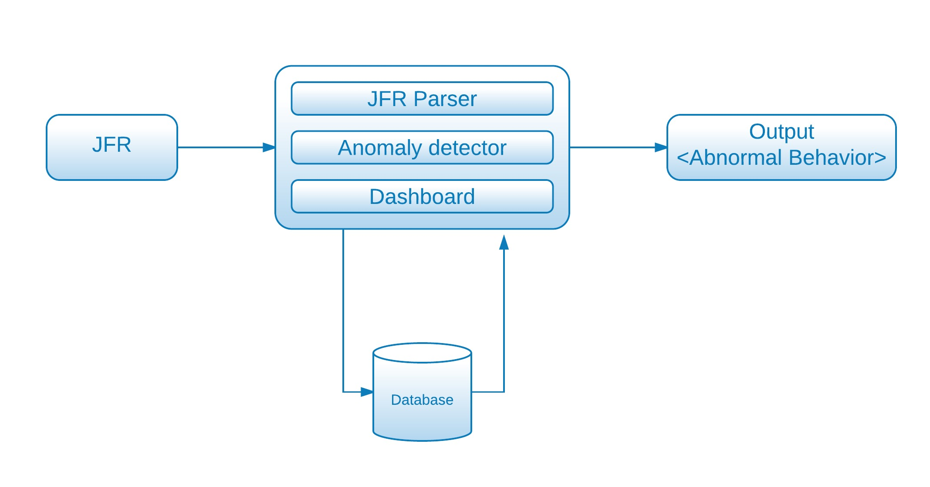

8.2. Abstract Architectural Diagram

8.2. Activity Diagram
This activity diagram shows the flow of activities of the JFR anomaly detection process.
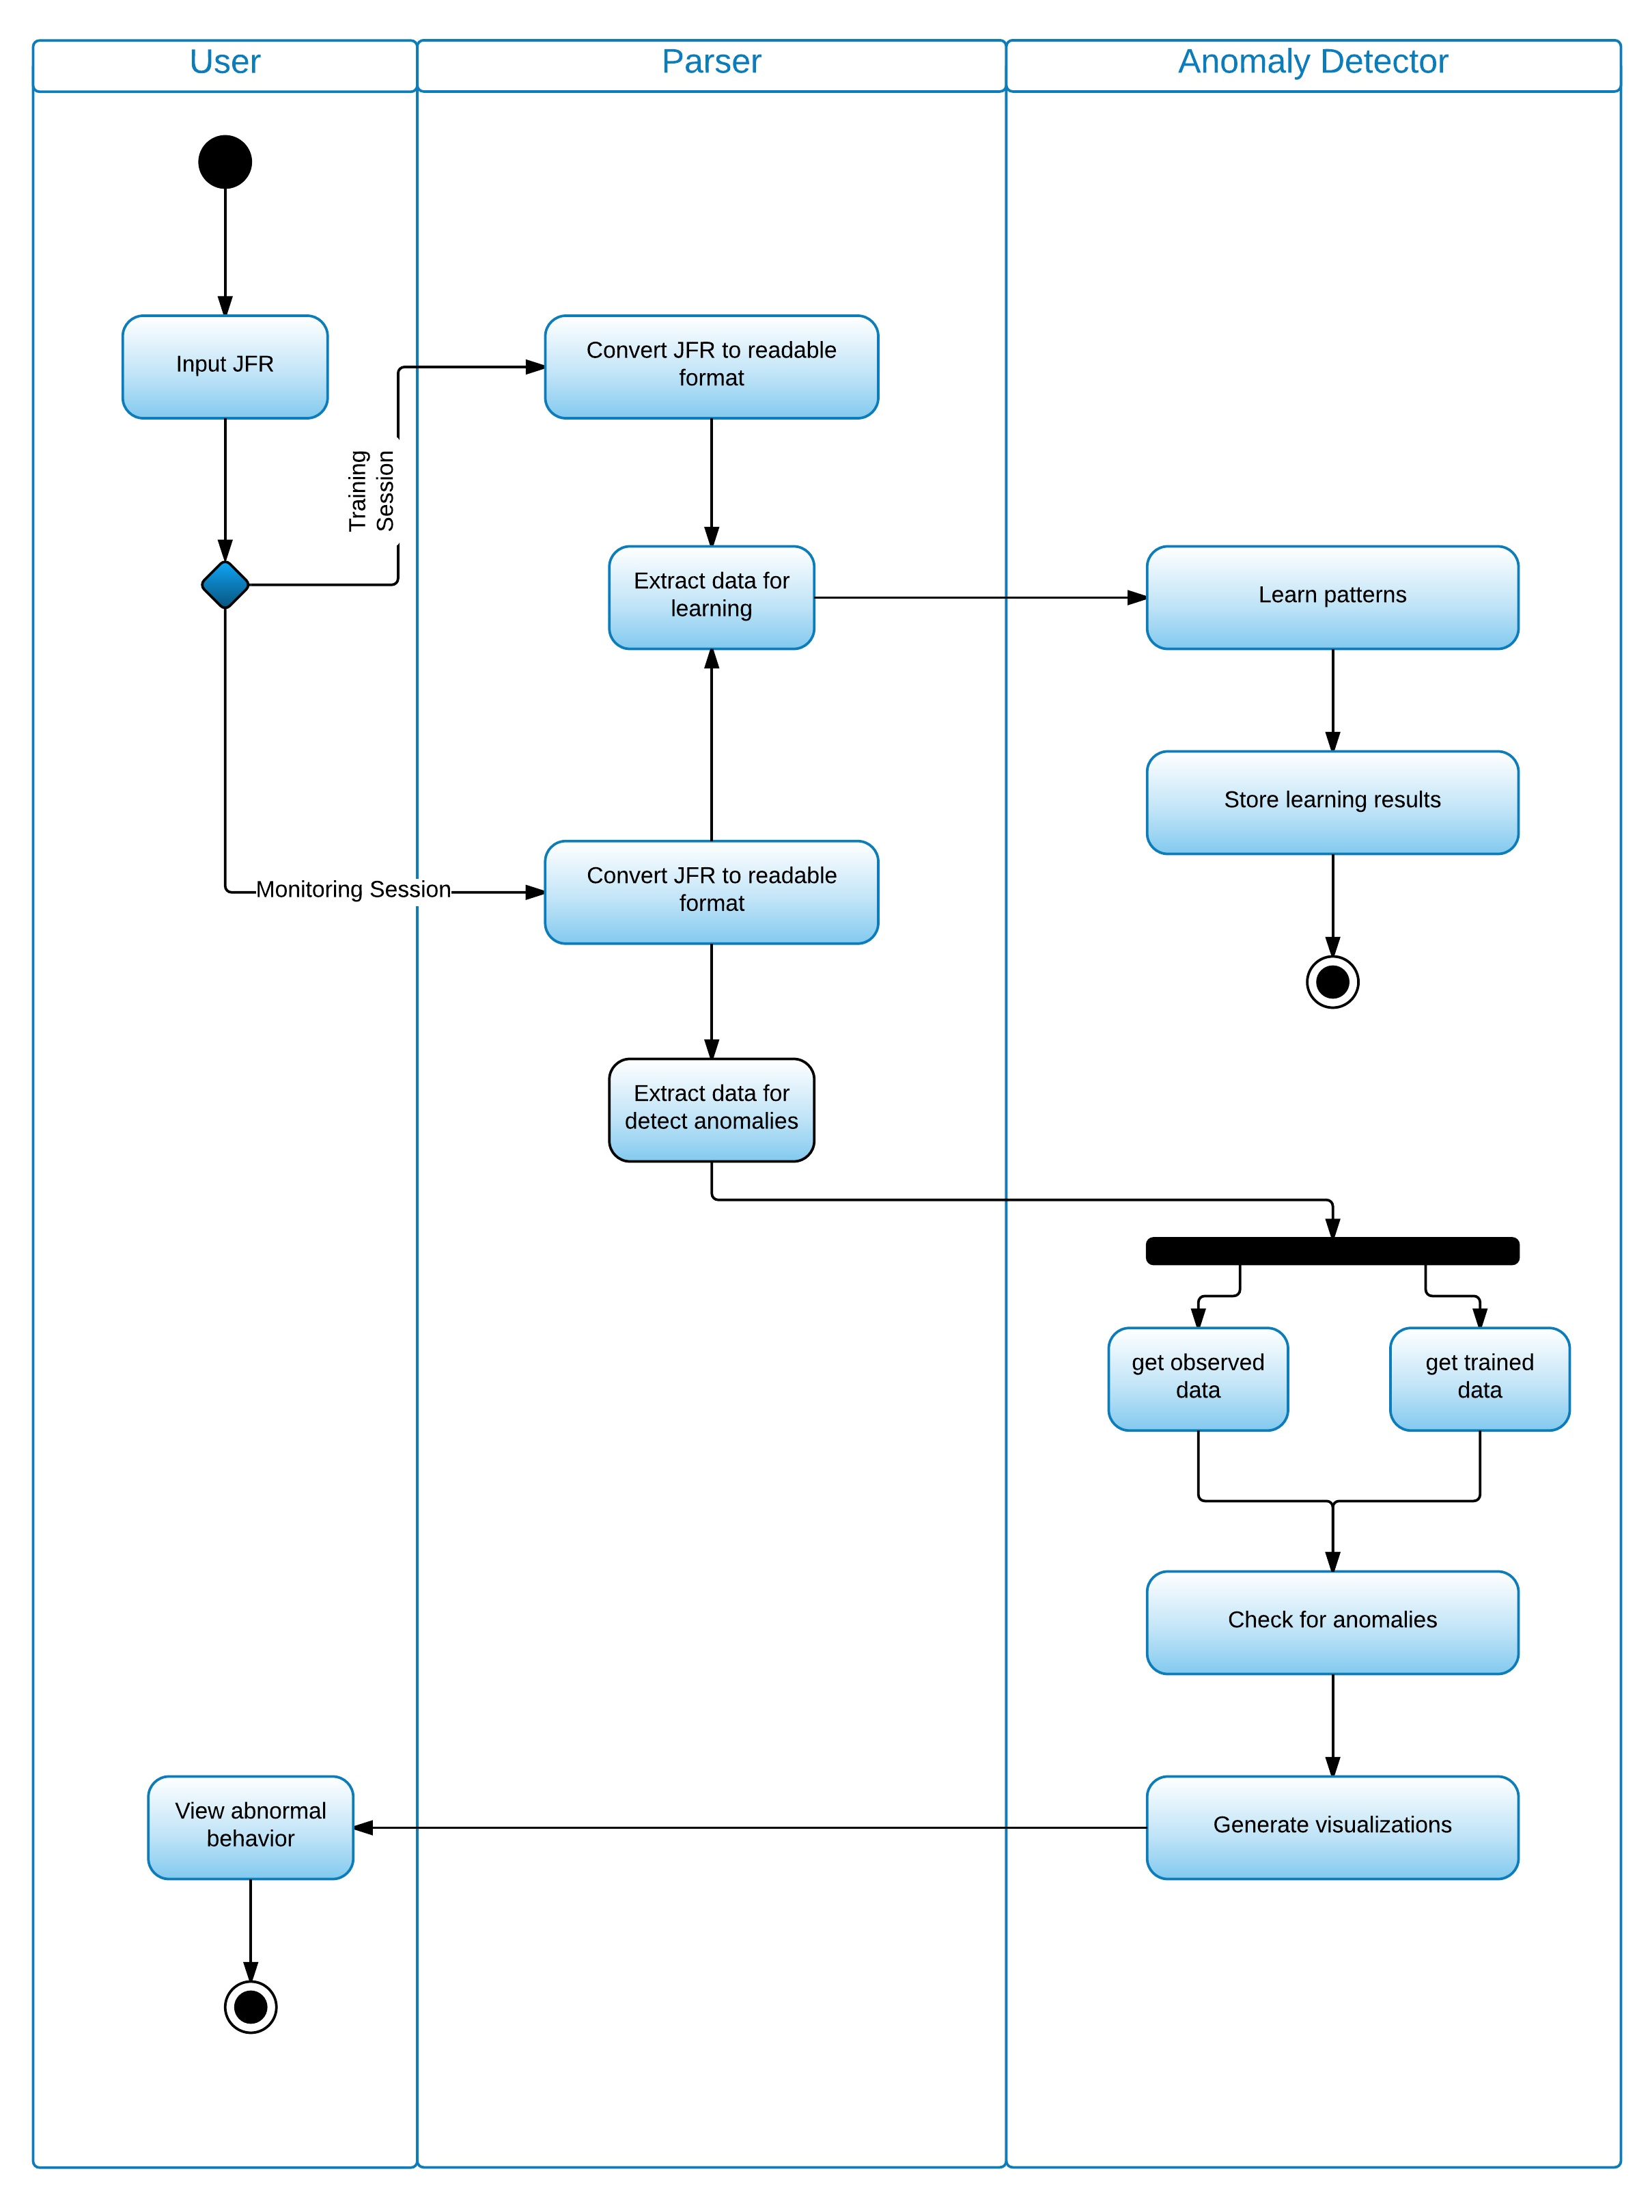

9. Proposed solution
JFR is a binary file that is created during the flight recording time in Java applications. JFR contains hundreds of event data which has information about runtime Java application such as CPU allocation, memory usage, I/O operations, garbage collection, code stack traces, etc. Therefore, it is essential to parse JFR dump into analyzable data structure. There are currently two parsers available now, Reference parser and JMC parser. JMC parser is fast and good for complex analysis whereas reference parser is slow and has only simple model and few APIs. Therefore, we can use JMC parsers to parse JFR dump into analyzable structure to satisfy objective 1.

We can employ machine learning algorithms such as clustering and time series to detect anomalies from Java application. Clustering is used to group similar type of data instances into clusters in unsupervised mode. We can divide clustering based anomaly detection into three types [19].

Normal data instances belong to a cluster in the data, while anomalies either do not belong to any cluster
Using the above technique if we can apply any clustering algorithm to any data set; a data set that does not belong to any of above will be labeled as an anomaly. We can use machine learning clustering algorithms such as, Density-based spatial clustering of applications (DBSCAN) and Shared nearest neighbor (SNN) for this purposes. Although we have a drawback here, that these algorithms are designed to find clusters not anomalies. Hence, we might encounter some optimization problems.

Normal data instances lie close to their closest cluster centroid, while anomalies are far away from their closest cluster centroid.
We can apply this technique in two steps, first we can cluster the data set using any clustering algorithms as suggested in the above technique and then secondly, we have to maintain an anomaly score, which is the distance to closest cluster centroid from the data point. We can use Self-organizing maps (SOM), K-means clustering algorithms to achieve this technique.

Normal data instances belong to large and dense clusters, while anomalies either belong to small or sparse clusters.
Here we declare anomalies by comparing cluster density or size against cluster threshold. Therefore, if the size/density is below the amount of threshold amount it will be labeled as an anomaly. There are few algorithms such as find CBLOF (find cluster based local outlier factor), where CBLOF scores can be used to maintain distance from cluster data and data belongingness to a cluster [34].

Another way of detecting anomalies is using time series algorithms such as Hidden Markov Model (HMM) or Long Short Term Memory Networks using Recurrent Neural Networks [16]. Hidden Markov model is discrete time doubly stochastic process one is Markov process express by states which are hidden; the other is observations sequence associate with states. It must possess a property called Markov property says that the probability of the next state depends only on the current state and not the sequences of events that preceded it. Hidden Markov Model is built using hidden states, observation states and transition and emission probabilities. HMM parameters generated using Baum-Welch algorithm also called learning problem of HMM.

We can use the Hidden Markov Model approach to build a model for each event that is captured during flight recording. Using the several JFR data we can build Hidden Markov Model and use the model to calculate the probabilities. Then we can find anomalies by the technique stated below.

One way is to use the threshold values. Calculate the accepted probabilities for several observation sequences of same length and different between the accepted probabilities of the new sequence and old sequence show less probabilities than the threshold values it identified as anomalies [5]. Hence, these two approaches satisfies objective 2.a.

We can come up with algorithms to automate performance analysis. For example, Java Flight Recorder can be used to record selected events during an execution of a Java program. Those trace events can be represented in one or more nodes in a tree data structure. We can give anomaly score by processing the performance statistics at each node to determine an overhead compensation value and applying the overhead compensation value to the performance statistics at each node [33]. Hence, this satisfies Objective 2.b. Altogether these two approaches satisfies objective 2.
We have already formatted the JFR dump into analyzable data (Objective 1 and Objective 2) and we have to create web services to pass values to the front end. There are so much visualizing libraries available in open source, such as, D3.js, Vega.js, WSO2-Vizgrammer, etc. Therefore using one of these libraries, we should be able to satisfy objective 3.

References
[1] Nong Ye. A Markov Chain Model of Temporal Behavior for Anomaly Detection. IEEE Workshop on Information Assurance and Security United States Military Academy, West Point, NY, 6-7 June, 2000

[2] L. R. Rabiner and B. H. Juang. An introduction to hidden Markov models. IEEE ASSP Mag, pp4-16, Jun 1986.

[3] Christina Warrender, Stephanie Forrest and Barak Pearlmutter. Detecting Intrusion Using System Calls: Alternative Data Models[C]. 1999 IEEE Symposium on Security and Privacy. IEEE Computer Society, 1999.

[4] Bin, Y., Qiao, Y., Xin, X.W., et al. Anomaly intrusion detection method based on HMM[J]. IEEE Electronic letters Online No: 20020467. 2002,38: 663–664.

[5] R. Alghamdi, "Hidden Markov Models (HMMs) and Security Applications", International Journal of Advanced Computer Science and Applications, vol. 7, no. 2, 2016.

[6] L. R. Rabiner, "A Tutorial on Hidden Markov Models and Selected Applications in Speech Recognition" Proceedings of the IEEE, Vol.77, No.2, 1989, pp.257-286.

[7] A. Patcha and J. Park, "An overview of anomaly detection techniques: Existing solutions and latest technological trends", Computer Networks, vol. 51, no. 12, pp. 3448-3470, 2007.

[8] C.S. Möller-Levet, F. Klawonn, K.-H. Cho, O. Wolkenhauer, Fuzzy clustering of short time series and unevenly distributed sampling points, Proceedings of the 5th International Symposium on Intelligent Data Analysis, Berlin, Germany, August 28–30, 2003.

[9] R.H. Shumway, Time–frequency clustering and discriminant analysis, Stat. Probab. Lett. 63 (2003) 307–314.

[10] T.-C. Fu, F.-L. Chung, V. Ng, R. Luk, Pattern discovery from stock time series using self-organizing maps, KDD 2001 Workshop on Temporal Data Mining, August 26–29, San Francisco, 2001, pp. 27–37.

[11] M. Ramoni, P. Sebastiani, P. Cohen, Bayesian clustering by dynamics, Mach. Learning 47 (1) (2002) 91–121.

[12] T. Warren Liao, "Clustering of time series data—a survey", Pattern Recognition, vol. 38, no. 11, pp. 1857-1874, 2005.

[13] E. Marchi, F. Vesperini, F. Eyben, S. Squartini, and B. Schuller, “A novel approach for automatic acoustic novelty detection using a denoising autoencoder with bidirectional LSTM neural networks,” in Acoustics, Speech and Signal Processing (ICASSP), 2015 IEEE International Conference on, vol. 289021, no. 289021, apr 2015, pp. 1996–2000.

[14] Zachary C. Lipton, “A Critical Review of Recurrent Neural Networks for Sequence
Learning,” pp. 1–35, 2015. [Online]. Available: http://arxiv.org/abs/1506.00019v2

[15] S. Hochreiter and J. Schmidhuber, “Long Short Term Memory,” Neural Comput., vol. 9, no. 8, pp. 1735–1780, Nov. 1997. [Online]. Available: http://dx.doi.org/10.1162/neco.1997.9.8.1735

[16] P. Malhotra, L. Vig, G. Shroff, and P. Agarwal, “Long Short Term Memory Networks for Anomaly Detection in Time Series,” in European Symposium on Artificial Neural Networks, no. April, 2015, pp. 22–24.

[17] P. Malhotra, A. Ramakrishnan, G. Anand, L. Vig, P. Agarwal, and G. Shroff. Lstm-based encoder-decoder for multi-sensor anomaly detection. 33rd International Conference on Machine Learning, Anomaly Detection Workshop. arXiv preprint arXiv:1607.00148, 2016.

[18]Chauhan, Sucheta and Vig, Lovekesh. Anomaly detection in ecg time signals via deep long short-term memory networks. In Data Science and Advanced Analytics (DSAA),2015. 36678 2015. IEEE International Conference on, pp. 1–7. IEEE, 2015.

[19] Chandola, V., Banerjee, A., Kumar, V.: Anomaly detection: A survey. ACM Computing Surveys (CSUR) 41(3), 15 (2009)

[20] Divya.Iyer, Arti Mohanpurkar, Sneha Janardhan, Dhanashree Rathod, and Amruta Sardeshmukh ”Credit card fraud detection using Hidden Markov Model” Information and Communication Technologies (WICT), IEEE , Mumbai, India ,11-14 Dec , 2011, pp 1062 – 1066.

[21] Z. Chen and Y. Li, "Anomaly Detection Based on Enhanced DBScan Algorithm", Procedia Engineering, vol. 15, pp. 178-182, 2011.

[22] E. Sperandio Nascimento and O. de Lira Tavares, "A Cluster-based Algorithm for Anomaly Detection in Time Series Using Mahalanobis Distance", Int'l Conf. Artificial Intelligence, 2015.

[23] Ashish Thakur, Bushra Shaikh, Vinita Jain, A. M. Magar “Hidden Markov Model in Credit Card Fraud Detection” International Journal of Advanced Research in Computer Science and Software Engineering, Volume 5, Issue 2, February 2015.

[24] A. Srivastava, A. Kundu, S. Sural and A. Majumdar, "Credit Card Fraud Detection Using Hidden Markov Model", IEEE Transactions on Dependable and Secure Computing, vol. 5, no. 1, pp. 37-48, 2008.

[25] K.M.C. Tan, R.A. Maxion, Determining the operational limits of an anomaly-based intrusion detector, IEEE Journal on Selected Areas in Communication 2 (2003) 96–110.

[26] Junshui Ma, Simon Perkins, “Time-series Novelty Detection Using One-class Support Vector Machines” , Space and Remote Sensing Sciences,Los Alamos, NM 87545.

[27] C. Kruegel, D. Mutz, W. Robertson, F. Valeur, Bayesian event classification for intrusion detection, in: Proceedings of the 19th Annual Computer Security Applications Con-
ference, Las Vegas, NV, 2003.

[28] J. Hipp, U. Güntzer, G. Nakhaeizadeh, Algorithms for association rule mining - a general survey and comparison, in: Proceedings of the ACM SIGKDD International Conference on Knowledge Discovery and Data Mining, Boston, MA, USA, 2000, pp. 58–64.

[29] W.W. Cohen, Fast effective rule induction, in: Proceedings of the 12th International Conference on Machine Learning, Tahoe City, CA, 1995, pp. 115–123.

[30] R.A. Calvo, M. Partridge, M.A. Jabri, A comparative study of principal component analysis techniques, in: Proceedings of the Ninth Australian Conference on Neural Networks, Brisbane, Qld, Australia, 1998.

[31] S. Forrest, S.A. Hofmeyr, A. Somayaji, T.A. Longstaff, A sense of self for unix processes, in: Proceedings of the IEEE Symposium on Research in Security and Privacy, Oakland, CA, USA, 1996, pp. 120–128.

[32] C. Warrender, S. Forrest, B. Pearlmutter, Detecting intrusions using system calls: alternative data models, in: Proceedings of the IEEE Symposium on Security and Privacy, Oakland, CA, USA, 1999, pp. 133–145.

[33] V.Cortellessa, A.Martens, R.Reussner, and C.Trubiani, “A Process to Effectively Identify guilty Performance Antipatterns,” in Fundamental Approaches to Software Engineering. Springer, 2010, pp. 368–382.

[34] W.Dickinson, D.Leon, and A.Podgurski,“Finding Failures by Cluster Analysis of Execution Profiles. In the proceeding of the 23rd International Conference on Software Engineering, May, 2001.

[36] J.-G.Lou, Q.Fu, S.Yang, Y.Xu, and J.Li, “Mining Invariants from Console Logs for System Problem Detection”, In proc. Of USENIX Annual Technical Conference, Boston, June. 2010.

[35] Kingsly Leung, Christopher Leckie, “Unsupervised Anomaly Detection in Network Intrusion Detection
Using Clusters” , ACSC '05 Proceedings of the Twenty-eighth Australasian conference on Computer Science - Volume 38 ,Pages 333-342.

